Group 11
Benjamin I. Cancel
Mikael Arguedas

Visual Servoing Homework

Pure Translation

- Along optical axis
For this case all three methods were able to bring our rover successfully back to the desired location with minimal errors.

- Orthogonal to optical axis
In this case both the holonomic and translation approach are able to bring us back to our desired location but the differential drive approach simply rotates until the image is at the desired angle. Since we cannot move linearly in the y direction this is as close as the differential drive method can get us.
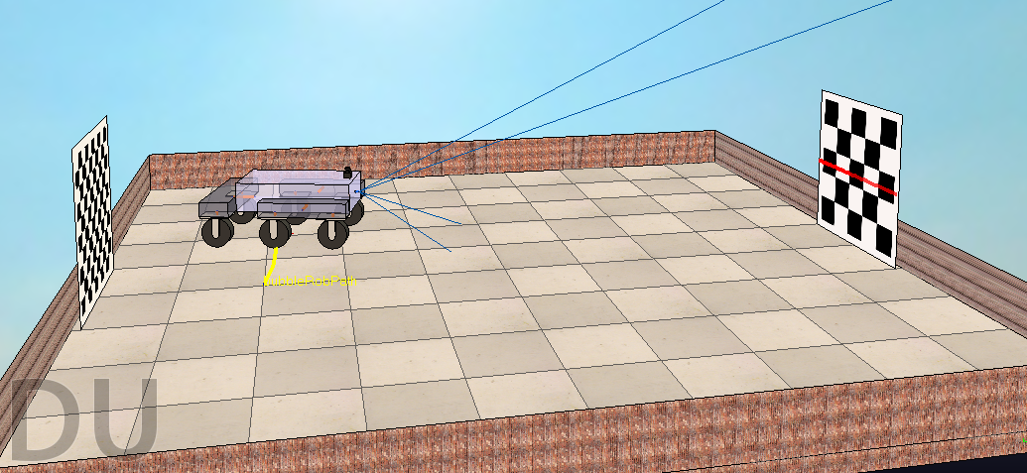

- Combined
When we combine translation along both axis again both the holonomic and translation methods are able to bring us back to our desired location but the differential drive method does not. What we can observe is that the image is in the correct location with respect to the robot and the correct distance away.
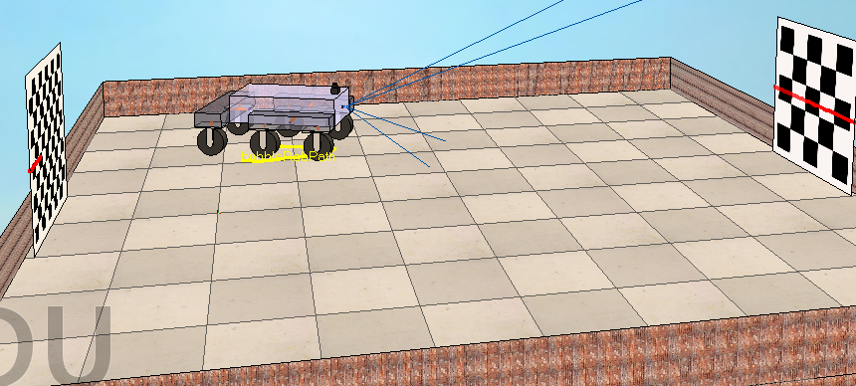

Pure Rotation

When we only apply a rotation both methods which are able to adjust our rotation perform perfectly bringing us back to our desired orientation. The last method, translations, is not able to bring us back and instead attempts to position the checkerboard at the center using the linear y velocity and at the correct distance with the linear x velocity.
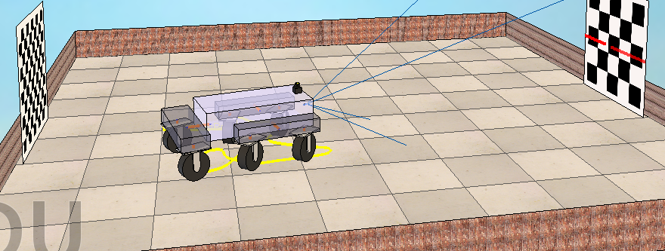

Combined translation and Rotation
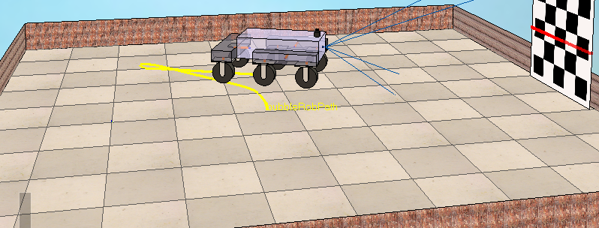
When we combine translation and rotation the holonomic aproach is the only one to bring us back to the desired location with the correct orientation. The translations mode still encounters the same problems explained above.

Likewise the differential drive mode encounters the same problems as with pure translation.
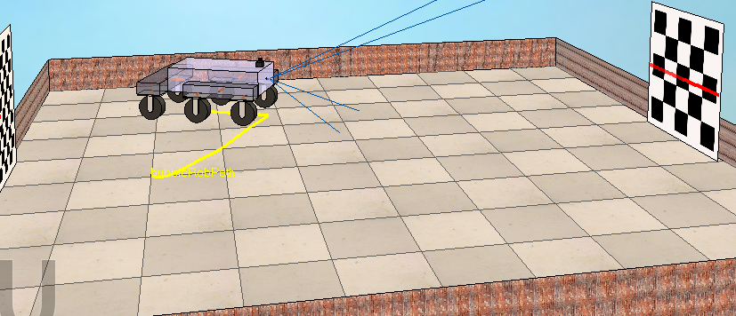

We found the algorithm to be only mildly sensitive to the correct value of Z. The value of Z has to be close to the correct value in order for us to be able to get to the correct location. A value of 1 for the dimensions of this world gives good results. However, if a value that was too large (we tried 5) was used we were no longer able to converge to the correct location.

When we used the LASER range sensor we saw that the distance is most of the time between 2 and 4 meters.

